Project Design Phase-II
Technology Stack (Architecture & Stack)

Date | 15 February 2026
Team ID | LTVIP2026TMIDS24256
Project Name | Heritage Treasures: An In-Depth Analysis of UNESCO World Heritage Sites in Tableau
Maximum Marks | 4 Marks

Technical Architecture:
The Deliverable shall include the architectural diagram as below and the information as per the table1 & table 2
Example: Order processing during pandemics for offline mode
Reference: https://developer.ibm.com/patterns/ai-powered-backend-system-for-order-processing-during-pandemics/
Technical Architecture
Architecture Overview
The system follows a 3-Tier Architecture:
1) Presentation Layer (Frontend)
User interacts through a Web Browser.
Dashboard is embedded using Flask.
Tableau Public displays interactive visualizations.
2) Application Layer (Processing Layer)
Tableau Desktop processes the dataset.
Data cleaning, calculated fields, filters, and forecasting
are applied.
Flask handles routing and webpage rendering.
3) Data Layer (Storage Layer)
UNESCO CSV Dataset (Local storage).
Tableau Workbook (.twb / .twbx file).
Published dashboard hosted on Tableau Public server.



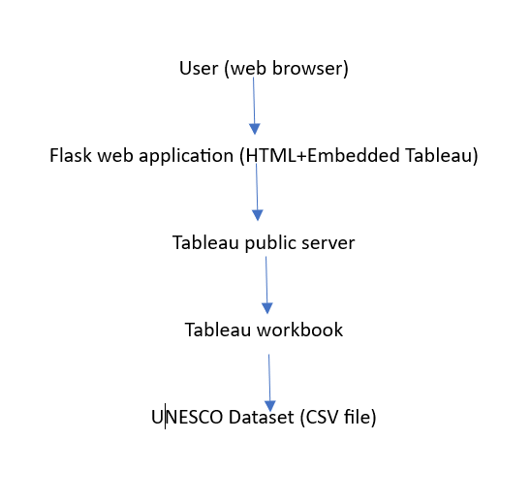
Table-1 : Components & Technologies:
S.No | Component | Description | Technology
 | User Interface | Web-based dashboard interface accessed via browser | HTML, CSS, Flask templates
 | Application Logic-1 | Data processing, filtering, calculated fields, forecasting | Tableau
 | Application Logic-2 | Web routing and embedding dashboard | Python flask
 | Application Logic-3 | Interactive filtering and dashboard controls | Tableau public
 | Database | Structured dataset storage | CSV file(UNESCO dataset)
 | Cloud Database | Online hosting of published dashboards | Tableau public
 | File Storage | Storage of dataset and Tableau workbook | Local file system
 | External API-1 | Public hosting and sharing of dashboards | Tableau public embed link
 | External API-2 | Dataset download source | Kaggle dataset platform
 | Machine Learning Model | Forecasting future heritage trends | Tableau built-in forecasting model
 | Infrastructure (Server / Cloud) | Deployment environment | Local system+ tableau+ public cloud

Table-2: Application Characteristics:
S.No | Characteristics | Description | Technology
 | Open-Source Frameworks | Web application framework used for embedding dashboard | Python Flask
 | Security Implementations | Read-only dashboard access, secure Tableau login for publishing | Tableau Authentication, HTTPS
 | Scalable Architecture | 3-Tier architecture allows independent scaling of presentation and data layer | Tableau Public + Flask
 | Availability | Dashboard hosted online and accessible 24/7 | Tableau Public Cloud
 | Performance | Optimized dashboards with limited filters and aggregated calculations | Tableau Optimization + Browser Rendering

References:
https://c4model.com/
https://developer.ibm.com/patterns/online-order-processing-system-during-pandemic/
https://www.ibm.com/cloud/architecture
https://aws.amazon.com/architecture
https://medium.com/the-internal-startup/how-to-draw-useful-technical-architecture-diagrams-2d20c9fda90d

